# **DATA FLOW**

* Data controls computation
* Structure of design determined by how data travels from component to component

Components: Data Flow Components:

* Interfaces are input/output ports
  + Read/write data
* Computation model: read data from input port, compute, write to output port

Connectors: Data Streams

* Doesn’t matter which direction they’re in (asynchronous, buffered)
* Interfaces are reader/writer roles
* Computational Model: transport data from writer roles to reader roles

**Types of Data Flow Architectures**

Batch Sequential

* Components (each step) are independent programs.
* Connectors (connecting components) are some media – usually magnetic tape
* Each step **runs to completion** before next step begins
* Usually for business data processing used (payroll computations, CRA tax return, etc.)



(Pipes & Filters)

* The tape of the batch sequential system, morphed into a language and operating construct
* Compared to the batch sequential style, data in pipe&filter is processed *incrementally*
* This style provides structure for systems that process a stream of data.
* Filters are independent with no shared state
* Correctness of output independent of order
* Data flows by 4 things
  + Pushing: pushes data in downstream direction
  + Pull: pulls data from upstream direction
  + Push/Pull: filter actively pulling data from stream, computing, pushing downstream
  + Passive: don’t do either, act as a sink or source for data
* Example systems = Scanning/Parsing, Unix Pipes, Image processing, voice/video stream



Pipe & Filter vs. Batch Sequential

* Batch = high latency (wait) period, P&F = process results right away
* Batch = external access to input, P&F = localized input

# **CALL-AND-RETURN**

* Used for information hiding (ADT, object, client/server)
* Hierarchical decomposition into subroutines (components) each doing a task or function
* Data passed as parameters
* Data Abstraction/Object Oriented
  + Uses objects or abstract data types
  + Connections in form of functions
  + Has multiple interfaces for objects
  + **Strengths:** = change implementation w/o affecting clients, break problems to small agents
  + **Weaknesses:** = to interact objects, must know identity (unlike pipe & filter), side effect problems: if A uses B and C uses B, then C effects on B can be unexpected to A

# **Interacting Processes**

**Communicating Processes**

* + LW Processes, Distributed Objects

**Event Systems**

* + Implicit invocation, pure events
    - Characterised by the style of communication between components
    - Instead of sending a message or calling a method directly, the component announced/broadcasts an event
    - Components register interest in event by associating procedure with it
    - When event is announced, system implicitly invokes all procedures registered with event
    - Components = modules with interfaces that provide collection of procedures/methods and events they can announce
    - Connectors = Binding between event announcements and method calls
    - **Example**: editor announces it finished editing module, compile registers for announcements and automatically recompiles module
    - **Example 2**: Debugger announces it reached breakpoint, editor registers interest in this and automatically scrolls to relevant source line.
    - Announcers of events do not know which components will be affected by those events
    - Components cant make assumptions about ordering of processing
      * Ex. User interfaces, Syntax editors, programming environment tools
    - Strengths = strong support for reuse, maintenance easy to add/replace components with little affect on other components in system
    - Weaknesses = Loss of control (don’t know results of announcing event or order done in)

**Model View Controller**

* + - Type of implicit invocation architecture style which decomposes interactive system into 3 components

1. Model containing core functionality and data
   1. Denote and implement the domain application data
2. One or more views displaying information to user
   1. Denote and implement different ways data presented to user
3. One or more controller handling user input
   1. Implement software logic that alters data in model









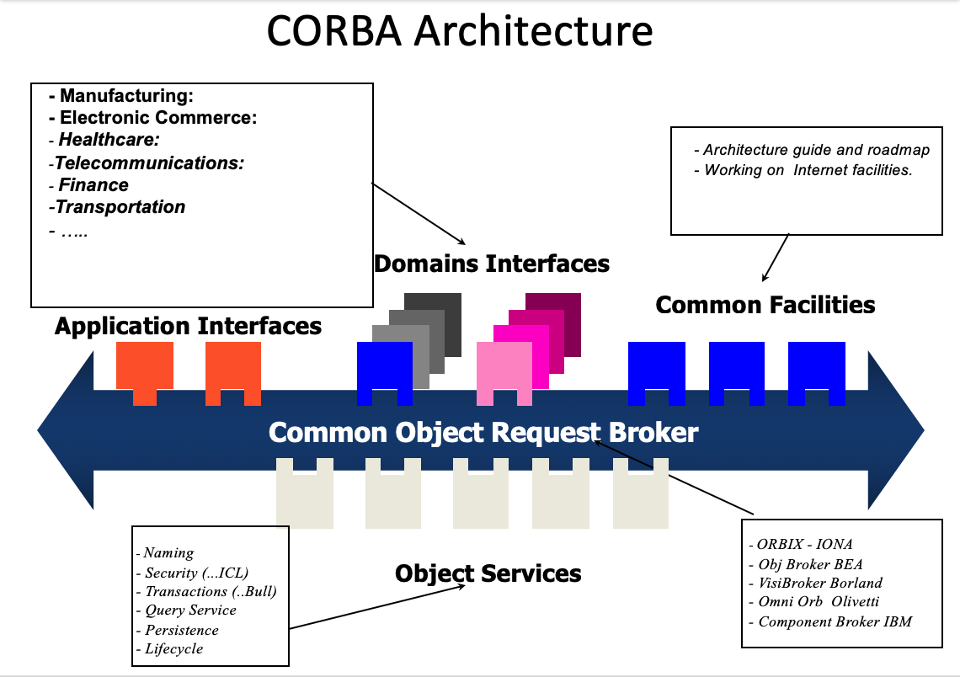

# **Data-Oriented Repository**

* Transactional databases (true client/server)
  + Characterised by central data store component representing system state
  + Collection of independent components that operate on data store
  + Have transactional databases (stream of transactions trigger processes to act on data store)
  + Also have Blackboard architecture (current state of data store triggers processes)
* **Blackboard**
  + Solvers collaborate to solve problem but don’t follow pre-defined strategy
  + Current state of solution stored in blackboard
  + Processes triggered by state of blackboard
  + Examples = any problem with no solution strategy, but has many different approaches that can be used to build partial/approximate solution
    - AI: vision, speech, pattern, and modern compilers
* 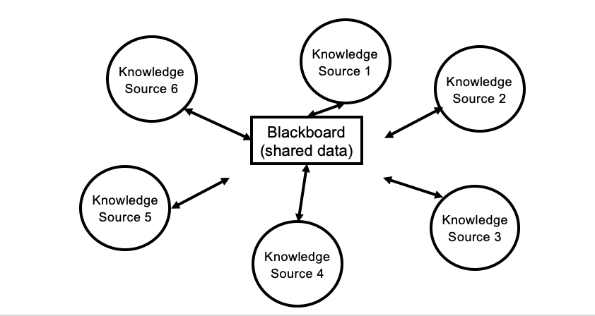

# **Data Sharing**

* Compound documents, hypertext, Fortran COMMON, LW processes

# **Hierarchical**

**Layered Systems**

* Organized hierarchically, each layer providing service to layer above and serving as client to layer below
* Used for large system with mix of high/low level issues, where high depend on low
* Components = group of subtasks which implement a “virtual machine” at some layer in hierarchy
* Connectors = protocols/interface that define how layers interact
* Examples = TCP/IP communications protocol used on internet (layers = ftp, tcp, ip)
* Example 2: operating systems (layers = hardware, kernel, etc.)
* **Strengths:** maintenance easy (layer above & below change), reuse, more abstract as we move up the layers – partitions complex problems
* Similar strengths to data abstraction/OO, similar to pipelines (comm. With at most one component on either side but with richer form)

